



**RFCA FOR YORKSHIRE AND THE HUMBER**

**RECRUITMENT PACK**

**FACILITIES MANAGEMENT OFFICER**



**RECRUITMENT PACK**

CONTENTS

1. ABOUT US
2. JOB DESCRIPTION AND SALARY
3. PERSON SPECIFICATION
4. APPLICATION PROCESS

**ABOUT US**

OUR STORY

**SO FAR**

At Reserve Forces’ and Cadets’ Association for Yorkshire and The Humber (RFCA YH) we champion Yorkshire and The Humber’s Reserve Forces’ and Cadets’ through community and corporate engagement, estate management and recruitment support to local Reserve Units and Cadet Detachments.

Reservists are an integral part of the Armed Forces, working side-by-side with their regular colleagues at home and overseas.

**OUR HISTORY**

We have been the voice for Yorkshire and The Humber’s Navy, Army and Air Force Reservists and Cadets since 1908.

**OUR TEAM**

As a small and committed team, we strive to promote the value and diverse skill set of the Armed Forces family to the local community and employers from all sectors.

**OUR WORK**

We provide informed support to Yorkshire and The Humber’s Armed Forces Community and use our locally driven relationships to deliver defence strategy at a regional level. Perhaps most crucially, we manage the Volunteer Estate, ensuring our Reservists and Cadets have the proper facilities to train in and thrive.

**OUR OBJECTIVES**

WHAT WE DO

**OUR VALUES**

TRUSTWORTHY Reliable, dependable and worthy of confidence

RESPECTFUL Of each other, the units we serve, our members and stakeholders

With INTEGRITY Truthful and sincere, genuine and candid

PROFESSIONAL In our processes, work and behaviours

**VISION STATEMENT**

To ensure Reserves and Cadets in Yorkshire and The Humber thrive and endure, enjoying strong and mutually supportive relationships with the communities of the region, and strengthen the relationships between the Armed Forces and civil society.

**THE THREE PILLARS**

**ENGAGEMENT CADETS AND YOUTH ESTATES**

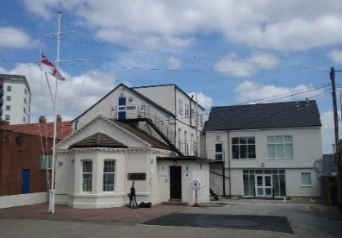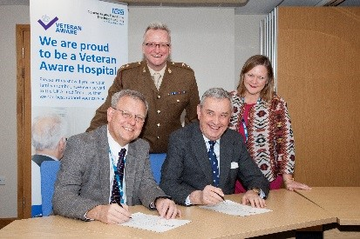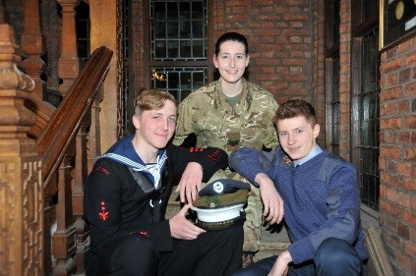

There are over 8,500 cadets across Yorkshire and the Humber; at RFCA YH we provide the financial, administrative and logistical support that enables them to take on challenges and adventures that would otherwise be unavailable to them.

Importantly, we provide the recruitment support for the adult volunteers without which the cadet organisations would cease to exist.

We work to establish and maintain strong relationships with employers and community stakeholders to develop mutually beneficial working relationship with the Ministry of Defence.

Our Engagement Team is here to advise and guide companies to adopt a forces friendly policy beginning with signing the Armed Forces Covenant, through their journey on the Employer Recognition Scheme to becoming advocates for Defence.

Our Estates Team manage 30 Reserve Centres across the region (including Maritime Reserve and Royal Auxiliary Air Force) along with 140 Cadet Training Centres.

We have successfully designed and project managed multi-million pound builds and provide all essential maintenance, repairs, leasing and safety compliance to the entire Reserve Estate.

**OUR IMPACT**

HOW WE DO IT

EMPLOYER AND COMMUNITY ENGAGEMENT

RFCAYH builds and nurtures enduring relationships with opinion formers, stakeholders, employers and local authorities, improving understanding of the reserve forces’ and cadets’ contribution to the nation and our area.

The team works with local authorities and statutory service providers to deliver the Armed Forces Covenant (AFC) across the region. All County Councils and unitary authorities in the region have signed the Covenant and implement their AFC in a way fitting with the values and ethos of their county. RFCAYH acts a key point of contact and a source of information on the Armed Forces Covenant, Reserves and Cadet matters.

##### CADET INITIATIVES AND ADULT INSTRUCTORS

The hard work of Yorkshire and The Humber’s 8,500+ cadets can be seen in the increasing number of events that they are involved in throughout the Region. These include Remembrance Day Ceremonies at various locations across the region.

In addition to administering annual camps, we have established combined events, giving cadets the opportunity to test their skills. Events such as the much sought after Lord-Lieutenant Cadet Certificate presentation is organised every year by the RFCA YH Youth and Cadets Team. Additionally we provide cadets the opportunity to be involved in events such as the annual photography competition, winter skills courses and kayaking in Norway.

In schools, our commitment to the Cadet Expansion programme is led by our dedicated School Cadet Expansion Officer. His role is to guide schools and offer advice throughout the process of establishing a Combined Cadet Force unit.



##### MANAGING THE ESTATE

The RFCA manages the estate for all Reservists and Cadets in the region, which includes 630 buildings, covering 6,500 acres of land and ranges from small cadet huts to multi-unit bases. Additionally, the RFCA manages multi-million pound works and estates budgets on behalf of the MoD, including adapting injured service personnel’s’ homes.

In addition to our core funding, we are required to source additional funding streams to meet these demands.

ALTERNATIVE VENUES (AV)

Alternative Venues manages the venue hire within RFCA YH. It is a non-profit organisation which generates additional funding by hiring out facilities within the RFCA YH Estate.

With over 30 Army Reserve Centres, 87 Army Cadet Force and 62 Air Training Corps sites spread across Yorkshire and The Humber available for commercial venue hire, the money generated by AV is put directly back in to the Estate.

**VACANCY**

JOB DESCRIPTION

# 

Post: Facilities Management Officer (FMO)

Department: Estates

Line Manager: Head of Estates

Grade: D

**General**

1. The FMO works within the Estates Department of the RFCA Y&H supporting the Head of Estates in the delivery of the following three key functions in order to contribute to the success of Cadets and Reserves thriving in Y&H:

* Alternative Venues income generation
* Soft Facilities Management
* Property Services

## Tasks

2. **Soft Facilities Management**:  Deliver soft facilities management across the Volunteer Estate (VE) by controlling the spend, forecasting, monitoring and the associated administration and co-ordination for the following:

* Provision of trade waste in accordance with the requirement, monitoring performance and expenditure.
* Provision of window cleaning, in accordance with the requirement, monitoring performance and expenditure.
* Occasional skip hire, provision and co-ordination.
* Provision of cleaning products within a delegated budget.
* Provision of RFCA laundry requirements.
* Collation and processing of site utility meter readings and invoices where appropriate.

3. **Property Services**: Manage the RFCA portfolio of property services and land management services, ensuring the data held is current, conducting associated administration, process management, control of information and engagement, including but not limited to:

* Lease management end-to-end process of cadet facilities for the ACF and ATC, driving the renewal process, investigating new premises, ensuring value for money, liaising with landlords, stakeholders and cadet forces, managing surrender, assessing impacts.
* Provision of current lease information in relation to response/reactive works and projects, to ensure compliance with the conditions of the lease, conveyance and consent.
* Maintaining the freehold property portfolio with current data, to enable strategic and operational decision making.  Assist in the disposals and requisition process when required.
* Manage the non-domestic rates process, liaising with local authorities conducting reviews and maintaining records.
* Manage Council tax payments, credits, notifications and assessments.
* Provide current property information for alternative venues income on request to assist decision making.

4. **Alternative Venues**:  Deliver the third party hiring enterprise (Alternative Venues), generating income, against an agreed target involving but not limited to:

* Seeking new clients and additional income generation opportunities.
* Engaging, negotiating terms, influencing and managing the relationship.
* Co-ordination of stakeholders including MOD site occupants, clients and interested parties.
* Provision of the relevant hiring documentation and process management.
* Ensuring all charges are paid, within the agreed timescales and monitoring.
* Providing compliance and assurance oversight of third party activities

5. Carry out any other relevant duties commensurate with their grade, as directed by the Head of Estates.

## **Health and Safety**

6. To be aware of and comply at all times, with the terms of the Association Health and Safety Policy Statement, which is posted on all staff notice boards throughout the Association’s sites.

## **Administrative**

7. The RFCA Chief Executive or Head of Estates may review the Job Description in the light of significant changes in responsibility, plus at each change of incumbent.

PERSON SPECIFICATION

|  |  |  |
| --- | --- | --- |
|  | **Essential** | **Desirable** |
| **Experience** |  |  |
| Experience working with facilities management processes | **🗸** |  |
| Working collaboratively with a variety of Stakeholders | **🗸** |  |
| Collating and analyzing data | **🗸** |  |
| Problem solving | **🗸** |  |
| Working accurately to meet deadlines and changing priorities | **🗸** |  |
|  |  |  |
| **Qualifications** |  |  |
| British Institute of Facilities Management (BIFM) Level 3 |  | **🗸** |
|  |  |  |
| **Skills and Abilities** |  |  |
| Self-motivated and able to work with minimal supervision | **🗸** |  |
| Ability to interact productively with colleagues and Stakeholders to build strong working relationships | **🗸** |  |
| Capable of articulating an argument clearly and persuasively | **🗸** |  |
| Able to assimilate information and draft reports that capture and summarize key points |  | **🗸** |
| Excellent oral and written communication skills | **🗸** |  |
|  |  |  |
| **Knowledge** |  |  |
| Good working knowledge of all Microsoft Office applications | **🗸** |  |
| Understanding of Invoice processes |  | **🗸** |
| Database management and data entry |  | **🗸** |
|  |  |  |
| **Any Additional Factors** |  |  |
| Willingness to work flexibly | **🗸** |  |
| Full driving license (Group B) | **🗸** |  |

APPLICATION PROCESS

Should you wish to discuss the vacancy please contact Jenny Robinson by emailing [yh-offman@rfca.mod.uk](mailto:yh-offman@rfca.mod.uk) where your enquiry can be responded to or redirected.

The closing date for applications is **4th February 2022.**

Candidates should send the completed application form to yh-offman@rfca.mod.uk. Please indicate, by **providing evidence**, how your experience, qualification, skills and knowledge either at work, or elsewhere, qualify you to undertake the duties and responsibilities set out in the main activities and key tasks of the Job Description.

The interview will take place at our offices in York, during week commencing **14th February 2022,**