



**RFCA FOR YORKSHIRE AND THE HUMBER**

**RECRUITMENT PACK**

**Compliance Officer**

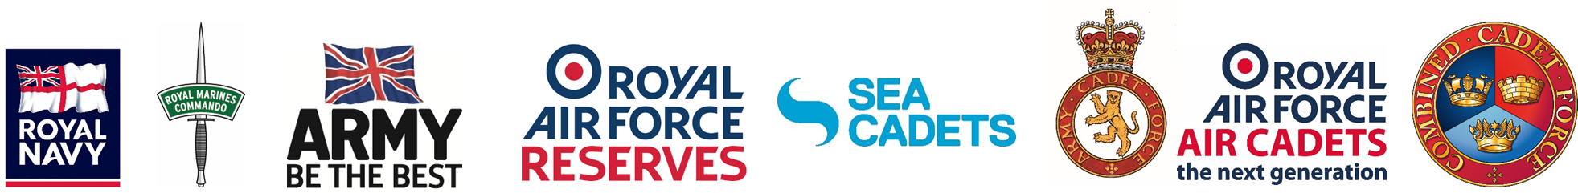

**RECRUITMENT PACK**

CONTENTS

1. ABOUT US 3
2. JOB DESCRIPTION AND SALARY 6
3. PERSON SPECIFICATION 10
4. APPLICATION PROCESS 12

**ABOUT US**

OUR STORY

**SO FAR**

At Reserve Forces and Cadets Association for Yorkshire and the Humber (RFCA YH) we champion Yorkshire and The Humber’s Reserve Forces’ and Cadets’ through community and corporate engagement, estate management and recruitment support to local Reserve Units and Cadet Detachments.

Reservists are an integral part of the Armed Forces, working side-by-side with their regular colleagues at home and overseas.

**OUR HISTORY**

We have been the voice for Yorkshire and The Humber’s Navy, Army and Air Force Reservists and Cadets since 1908.

**OUR TEAM**

As a small and committed team, we strive to promote the value and diverse skill set of the Armed Forces family to the local community and employers from all sectors.

**OUR WORK**

We provide informed support to Yorkshire and The Humber’s Armed Forces Community and use our locally driven relationships to deliver defence strategy at a regional level. Perhaps most crucially, we manage the Volunteer Estate, ensuring our Reservists and Cadets have the proper facilities to train in and thrive.

**OUR OBJECTIVES**

WHAT WE DO

**OUR VALUES**

TRUSTWORTHY Reliable, dependable and worthy of confidence

RESPECTFUL Of each other, the units we serve, our members and stakeholders

With INTEGRITY Truthful and sincere, genuine and candid

PROFESSIONAL In our processes, work and behaviours

**VISION STATEMENT**

To ensure Reserves and Cadets in Yorkshire and The Humber thrive and endure, enjoying strong and mutually supportive relationships with the communities of the region, and strengthen the relationships between the Armed Forces and civil society.

**THE THREE PILLARS**

**ENGAGEMENT CADETS AND YOUTH ESTATES**

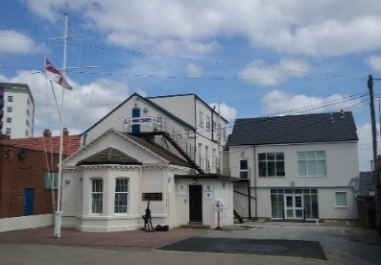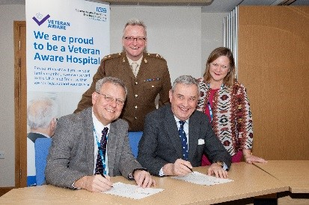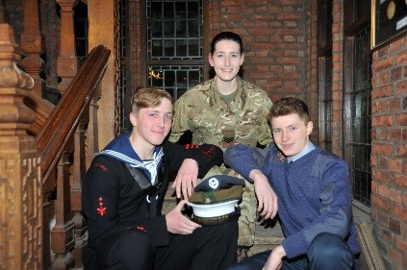

There are over 8,500 cadets across Yorkshire and the Humber; at RFCA YH we provide the financial, administrative and logistical support that enables them to take on challenges and adventures that would otherwise be unavailable to them.

Importantly, we provide the recruitment support for the adult volunteers without which the cadet organisations would cease to exist.

We work to establish and maintain strong relationships with employers and community stakeholders to develop mutually beneficial working relationship with the Ministry of Defence.

Our Engagement Team is here to advise and guide companies to adopt a forces friendly policy beginning with signing the Armed Forces Covenant, through their journey on the Employer Recognition Scheme to becoming advocates for Defence.

Our Estates Team manage 30 Reserve Centres across the region (including Maritime Reserve and Royal Auxiliary Air Force) along with 140 Cadet Training Centres.

We have successfully designed and project managed multi-million pound builds and provide all essential maintenance, repairs, leasing and safety compliance to the entire Reserve Estate.

**OUR IMPACT**

HOW WE DO IT

EMPLOYER AND COMMUNITY ENGAGEMENT

RFCA YH builds and nurtures enduring relationships with opinion formers, stakeholders, employers and local authorities, improving understanding of the reserve forces’ and cadets’ contribution to the nation and our area.

The team works with local authorities and statutory service providers to deliver the Armed Forces Covenant (AFC) across the region. All County Councils and unitary authorities in the region have signed the Covenant and implement their AFC in a way fitting with the values and ethos of their county. RFCAYH acts a key point of contact and a source of information on the Armed Forces Covenant, Reserves and Cadet matters.

##### CADET INITIATIVES AND ADULT INSTRUCTORS

The hard work of Yorkshire and The Humber’s 8,500+ cadets can be seen in the increasing number of events that they are involved in throughout the Region. These include Remembrance Day Ceremonies at various locations across the region.

In addition to administering annual camps, we have established combined events, giving cadets the opportunity to test their skills. Events such as the much sought after Lord-Lieutenant Cadet Certificate presentation is organised every year by the RFCA YH Youth and Cadets Team. Additionally we provide cadets the opportunity to be involved in events such as the annual photography competition, winter skills courses and kayaking in Norway.

In schools, our commitment to the Cadet Expansion programme is led by our dedicated School Cadet Expansion Officer. His role is to guide schools and offer advice throughout the process of establishing a Combined Cadet Force unit.



##### MANAGING THE ESTATE

The RFCA manages the estate for all Reservists and Cadets in the region, which includes 630 buildings, covering 6,500 acres of land and ranges from small cadet huts to multi-unit bases. Additionally, the RFCA manages multi-million pound works and estates budgets on behalf of the MoD, including adapting injured service personnel’s’ homes.

In addition to our core funding, we are required to source additional funding streams to meet these demands.

ALTERNATIVE VENUES (AV)

Alternative Venues manages the venue hire within RFCA YH. It is a non-profit organisation which generates additional funding by hiring out facilities within the RFCA YH Estate.

With over 30 Army Reserve Centres, 87 Army Cadet Force and 62 Air Training Corps sites spread across Yorkshire and The Humber available for commercial venue hire, the money generated by AV is put directly back in to the Estate.

**VACANCY**

JOB DESCRIPTION

Post: Compliance Officer

Department: Estates

Line Manager (LM): Head of Estates (HofE)

Grade: C2

**General**

1. The Compliance Officer delivers professional support, advice and guidance to the Senior Leadership Team (SLT) in all Safety, Health, Environmental and Fire (SHEF), compliance and matters and provides Soft FM facilities management across the YH RFCA estate. In addition they will carry out a number of logistic functions in relation to accounting for stores and management of tenancy agreements.

**Primary Role – Health, Safety and Compliance**

1. Responsible for all compliance aspects of the RFCA YH Estate, including:
2. Collation and promulgation of assurance and compliance data to the RPOC, Heads of Establishment, CRFCA and RFCA YH.

1. Auditing and checking compliance by Contractors on site on a bi-annual basis.
2. Control of a delegated budget of circa £120k (total £300k for post)
3. Development and maintenance of Estates Risk Assessments and Registers.

e. To act as the SHEF Coordinator at 20 St George’s Place, York, YO24 1DS and as the focal point for Health and Safety mandatory and statutory compliance across the RFCA estate.

f. To act as the focal point within the RFCA Estate for all Legionella and Asbestos Management related issues.

g. To act as Health & Safety Co-ordinator for the day-to-day control of the RFCA estate Health and Safety policy and procedures ensuring the Management Board and Property Assurance Board are kept up to date.

h. Carry out biennial visits to the ACF and CCF locations throughout the RFCA estate to ensure that the infrastructure complies with current Health and Safety legislation and where appropriate, inform the relevant Estate Surveyor of any instance of non-compliance, requesting that remedial action be taken.

**Secondary Role – Soft Facilities Management**

1. Responsible for the overall provision of soft facilities management , including:

1. Control of associated delegated budgets of circa £180k (total of £300k for post)
2. Line manage 2 members of the Estates team.
3. Management of refuse contracts for all Army Reserve Centres.
4. Management of collating utilities information to enable accurate forecast of usage and bills.
5. Negotiating contracts to ensure delivery of functions such as window cleaning.
6. Accommodation and Wider Markets Activity
7. Be the focal point for requests for the use of the ArmyReserve/ACF estate.
8. Confirm the availability/permission to use the venue with the units and obtain clearance through HQ 4 Brigade for police use or other emergency service use.
9. Negotiating letting rates.
10. Manage tenancy agreements.
11. Administer long-term lets for tenants such as SSAFA, RFEA, MPC, Skillforce and rifle clubs.
12. Using the Events Booking System, monitor and ensure payment of all rents and monies owing.
13. Totley Range. Supervision, detailing tasks and arranging for payment of the part-time warden.

## Administrative

1. The Chief Executive may review this Job Description in the light of changes in responsibility or at a change of incumbent.
2. Undertake all other duties as directed by the HoE commensurate with competencies held and the grade of this post.
3. As an Association Management employee, set and require the highest standards of professional conduct and contribute to a positive working environment.

PERSON SPECIFICATION

|  |  |  |
| --- | --- | --- |
|  | **Essential** | **Desirable** |
| **Experience** |  |  |
| Experience in a health and safety role, delivering and maintaining compliance. | **🗸** |  |
| Practical experience of Facilities Management | **🗸** |  |
| Contract management experience |  | **🗸** |
| Control of a delegated budget |  | **🗸** |
| Risk Assessments and Risk Registers | **🗸** |  |
| Delivering oral and written briefings | **🗸** |  |
|  |  |  |
| **Qualifications** |  |  |
| Nebosh or equivalent Health and Safety qualification | **🗸** |  |
| British Occupational Hygiene Society, Management of Asbestos in Buildings qualification or equivalent |  | **🗸** |
| NEBOSH or equivalent construction related Health and Safety qualification |  | **🗸** |
|  |  |  |
| **Skills and Abilities** |  |  |
| Self-motivated and able to work with minimal supervision | **🗸** |  |
| Ability to interact productively with colleagues and Stakeholders to build strong working relationships | **🗸** |  |
| Capable of articulating an argument clearly and persuasively | **🗸** |  |
| Able to assimilate information and draft reports that capture and summarize key points |  | **🗸** |
| Able to use all Microsoft Office applications competently | **🗸** |  |
|  |  |  |
| **Knowledge** |  |  |
| Understanding of the MOD chain of command |  | **🗸** |
| Knowledge of the Armed Forces, Reserves and Cadets |  | **🗸** |
| Excellent working knowledge of Health and Safety Legislation | **🗸** |  |
| Understanding of Legionella Management procedures |  | **🗸** |
| Understanding of Asbestos Management procedures |  | **🗸** |
|  |  |  |
| **Any Additional Factors** |  |  |
| Willingness to work flexibly | **🗸** |  |
| Full driving license (Group B) | **🗸** |  |

APPLICATION PROCESS

Should you wish to discuss the vacancy please contact Jenny Robinson by emailing [yh-offman@rfca.mod.uk](mailto:yh-offman@rfca.mod.uk) where your enquiry can be responded to or redirected.

The closing date for applications is **17th June 2021.**

Candidates should send the completed application form to yh-offman@rfca.mod.uk. Please indicate, by providing evidence, how your experience, qualification, skills and knowledge either at work, or elsewhere, qualify you to undertake the duties and responsibilities set out in the main activities and key tasks of the Job Description.

Successful applicants will be notified of an invitation to interview by **21st June 2021**.

Subject to national restrictions, it is intended to hold face to face interviews, in a COVID secure environment in York, on **2nd July 2021**